

**Mobile application project on marker based Augmented reality implementing coloring textures Library on a shooter game.**

**Super duck Shooter**

**Winter Semester 2017, Fulda**

**Author:**

Norman Lista ([normanusb@gmail.com](mailto:Normanusb@gmail.com))

Matrikel-Nr.:146900

**Introduction and explanation of the project:**

This document introduces the structure, and methods used for the development of the AR Game “Super duck shooter”, which implements different AR libraries together to form a unique base for a game, the project is an alpha version since its made to explain the use of the libraries and algorithms, more than the design and gameplay.

The application uses the AR coloring real-time texturing library, with the Unity engine, and the Vuforia Tools for AR marker targets, plus shooter game algorithms together, to build the structure of the game.

The game uses a marker which is a drawing, the drawing is recognize by the camera with the Vuforia tools, and creates a 3D version of the drawing on the camera using the texturing library, and renders the drawing texture that is on the scene on top of the 3D model, the user can add color to the marker by painting it with crayons or any other colors, and it will be reflected on the 3d model of the drawing.

To make it a shooter game the drawing is used as the character that shoots on the game, a player can customize his character by painting it the colors he likes, as soon as the game starts a pile of geometric forms appear in front of the camera, and by having the marker drawing on front, the character also appears, if the user touches the screen of the phone the character will throw a ball to the front, the goal of the game is to make the character throw all the geometric figures down with the balls, once it is done, the next level appears until the 3 levels are done and the game is over.

This document shows all the details on the creation of the game.

**Tools: Unity and Vuforia tools:**

Unity is a 3D development program, to create application for any console or smartphone using the programming language C#, Vuforia adds to the program tools for working on augmented reality applications, such as the AR cameras, and the Markers for the Marker based Applications, which where both used to create this game.

In this image the characters marker is added, in this case is a duck .

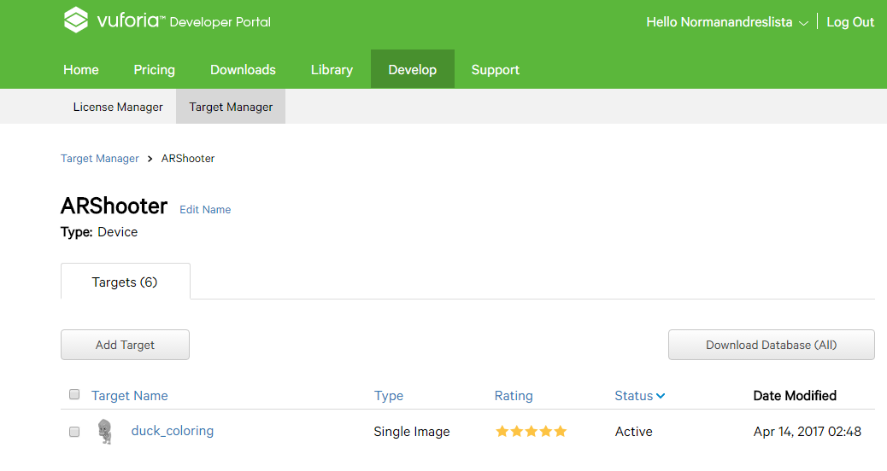

And in this one we can see the vuforia script for the AR camera to work:

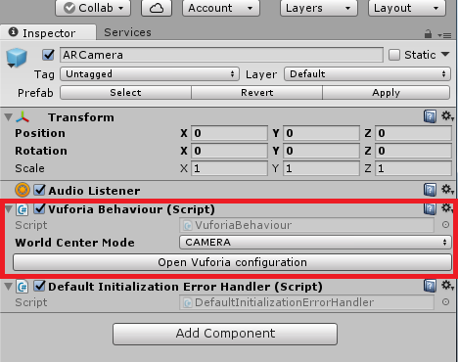

**Region capture package:**

For the texturing a package called Region captured is used, it was made by Computer vision , a company that develops AR technologies for Vuforia , the package can be download at <https://github.com/maximrouf/RegionCapture> the library is based on the paper “Live Texturing of Augmented Reality Characters from Colored Drawings” made by Stephane Magnenat, Dat Tien Ngo, Fabio Zund, Mattia Ryffel, Gioacchino Noris, Gerhard Rothlin, Alessia Marra, Maurizio Nitti, Pascal Fua, Markus Gross, Robert W. Sumner, That can be found in the extras at the end of this document.

The package uses the algorithm by capturing with the AR camara a region set by the image target, and rendering it on the 3D model at the same time , this way all the colors and changes made to the image target, are rendered.

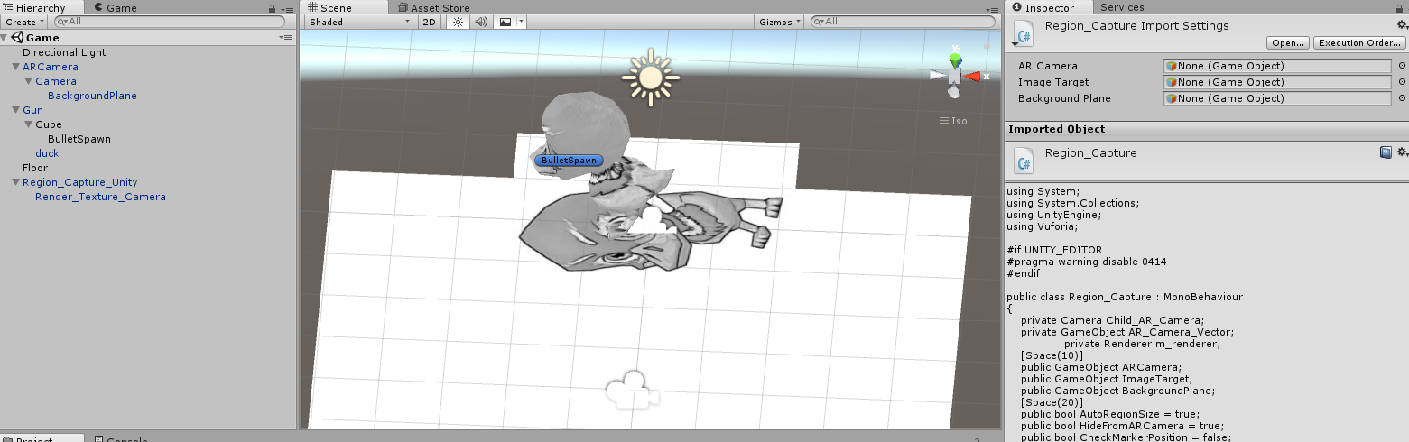

**Scripts used for the game:**

The game has 4 main scripts that make all the structure, the “Menu manager” for the game start screen, the “Game Manager” for the mechanics, change of levels and end of the game, “Gun” for the characters shooting settings and the “Block” for the level blocks to be shoot in the game.

**Menu manager:**

This script only makes sure that when the play button is clicked, the game scene starts.

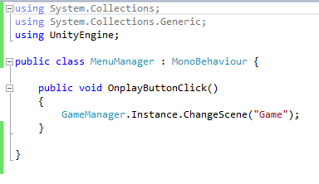

**Gun:**

When the screen is touched, a bullet is created and thrown with a velocity and force, with a rigid body to make it able to crash with other objects.

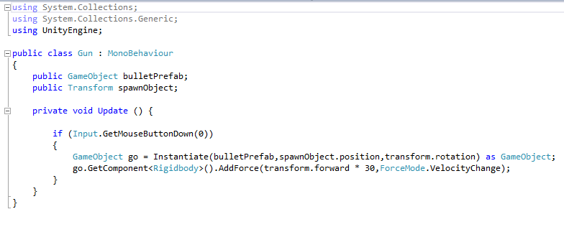

**Block:**

The block script checks every second the position of each block, if is moved then the blocked is removed, it is attached to the block object on the unity scene.

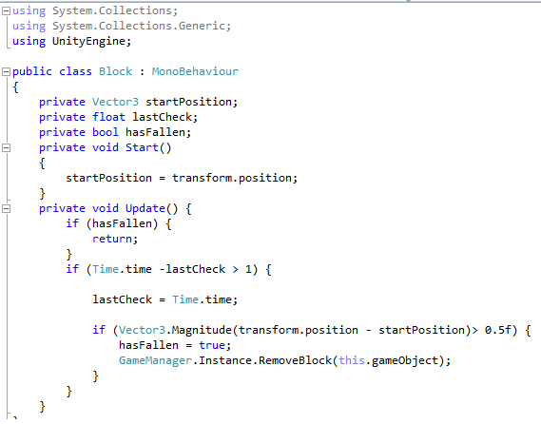

**Game Manager:**

The levels are defined by a set of blocks created on unity, they are handled by a List object in the Game manager, when the game is load or completed by the user, it starts the menu.

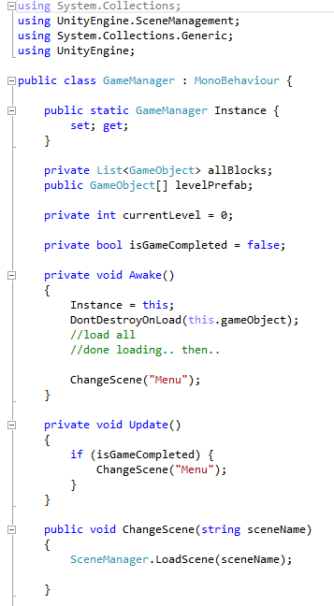

If all the blocks are removed from the scene then the level is over and the new one is created.

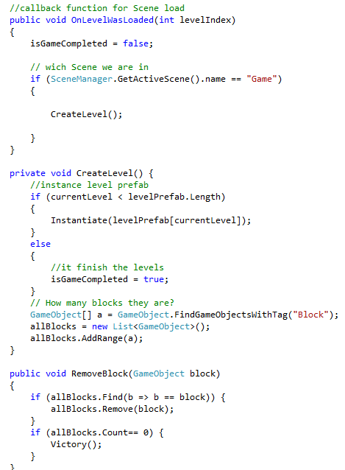

If the level is complete it removes all the blocks and bullets thrown , and starts the new level.

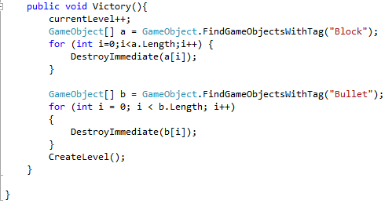

Each of the scripts are attached to the objects in the unity software so they can recognize each other:

Menu manages attached to MenuManager object in the menu scene:

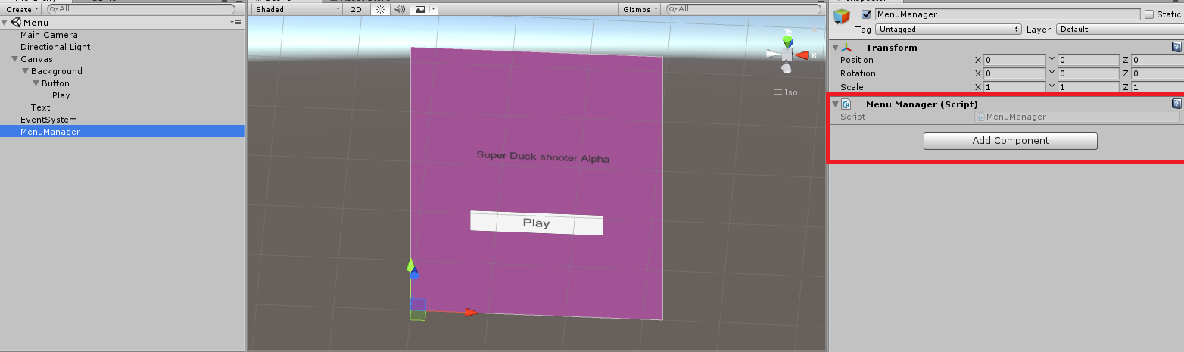

Game Manager attached to the preLoader scene, with each level attached to it:

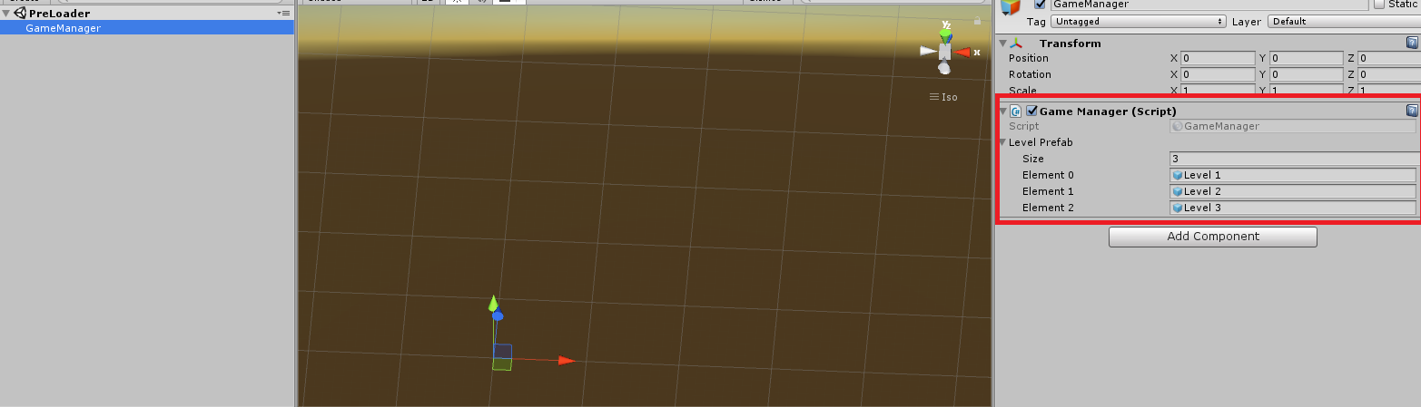

Gun script attached to the Gun in the game scene, to throw the bullets by the bullet Spawn object:

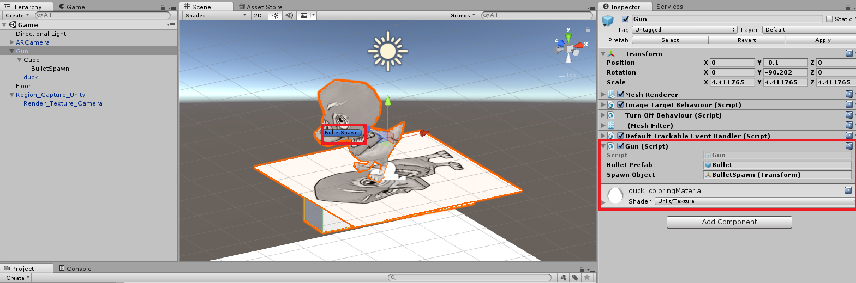

This way we combine the gun object script with the Region capture and create the shooting game with character customization by rendering color from the target image.

**Extras:**